Yuyi Zhang
Oct 04, 2020
Fall 2020 CPS Quarter
Instructor: Dr. Steward Huang
Module 3:
Classification Using Decision Tree and Rules
ALY 6020_Predictive Analytics

Introduction
In this report, we are going to practice two classification methods, the Decision Trees and the Rule learners. These are two algorithms that more focus on text content classification. The Decision Trees build flowchart structures, while the Rule learners generate logical if-else statements. The two cases we are going to go through are credit dataset and mushroom dataset. We are going to build up models to predict default of loans and types of mushrooms in the next two sections.

Analysis

Statlog (German Credit Data) Data Set

Step 1 – collecting data
After the global financial crisis in 2007 – 2008, people realized the importance of compliance in banking practices. One way to emphasize that is to apply deep learning for risk management. The credit dataset contains 1,000 observations of 21 variables. We are going to build a Decision Tree to future distinguish the default of loans.

Step 2 – exploring and preparing the data
Importing data to the R studio and take a look at the structure.
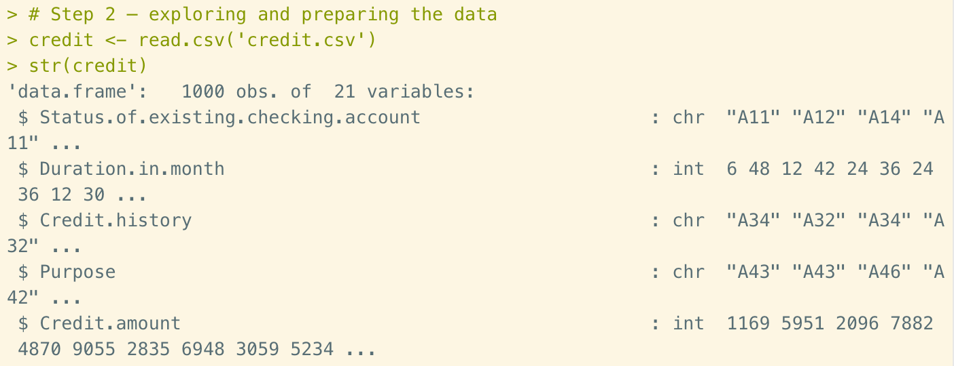
Figure 1. Importing data and structure
As we can see from the structure page, there are different type of values, such as characters and integers. the default vectors indicate applicants who may or may not be able to pay back the loan from the bank. In this report, we are going to generate a classification model to distinguish default observations, so that the bank will be able to reject credit requests base on numeric evidence. Let’s take a look at the portion of default in our dataset.
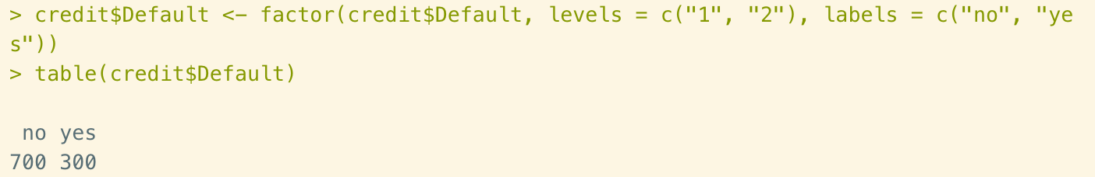
Figure 2. Default portion
The observations in this dataset are not randomly ordered. So, before we split the data into training data and test data, let’s solve this problem by generating a random sample.
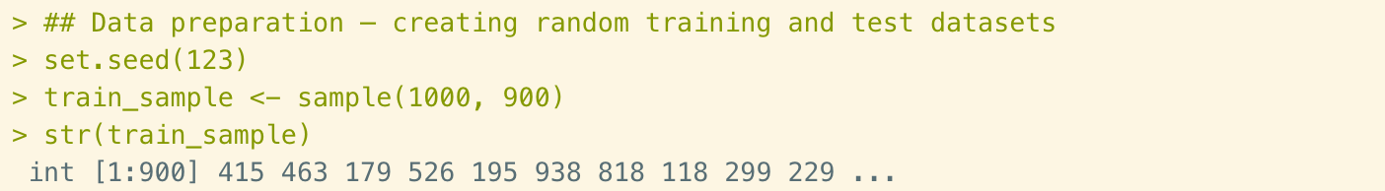
Figure 3. Random sample
Then separate the dataset by 90% of training data and 10% of test data and check out the portion of default observations in both datasets.
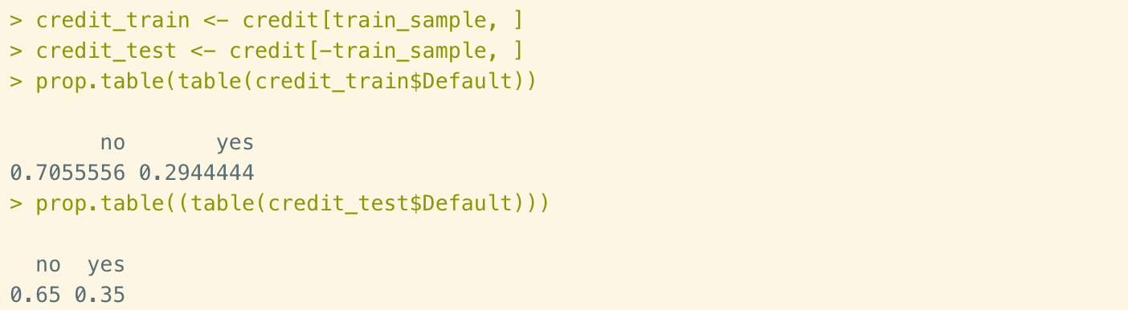
Figure 4. Dividing dataset into training data and test data

Step 3 – training a model on the data
In this step, we are going to use C5.0 algorithm to train our decision tree model. The function of c5.0() is:
M <- c5.0 (train, class, trials = 1, costs = NULL)
We use all columns except the default class variables in the 21st column. Then apply the last column as the target vector for c5.0() function.
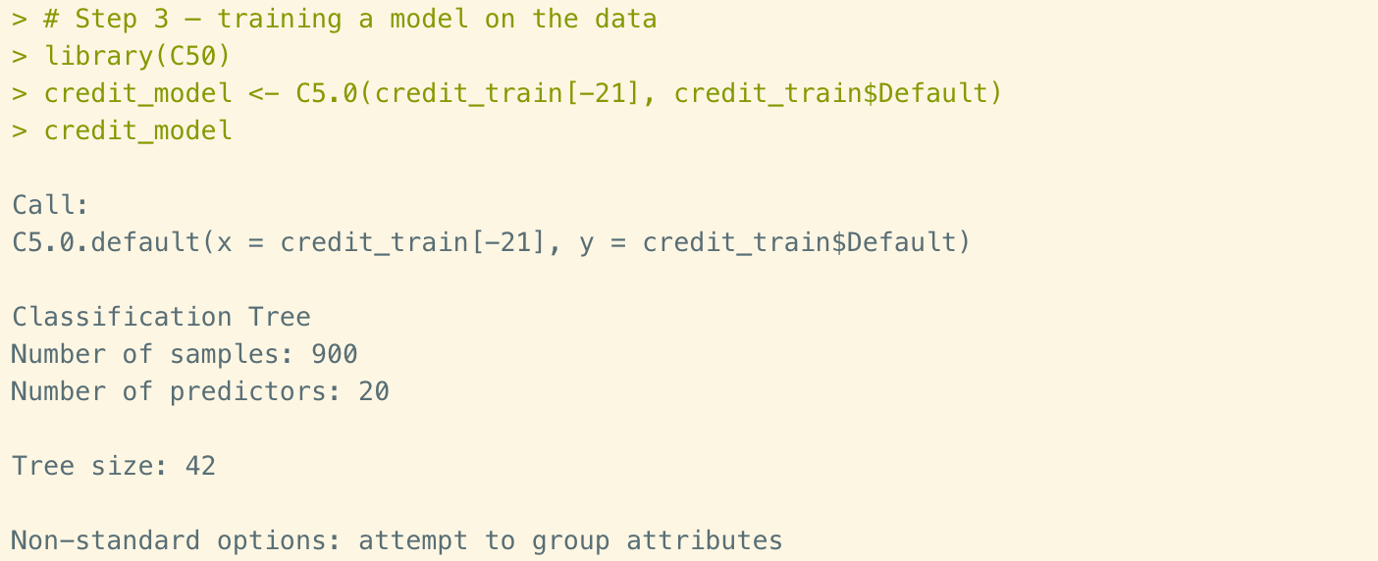
Figure 5. Training the model
As we can see from the basic data, the listed tree size is 42. Let’s take a look at how the decision tree look like in brief.
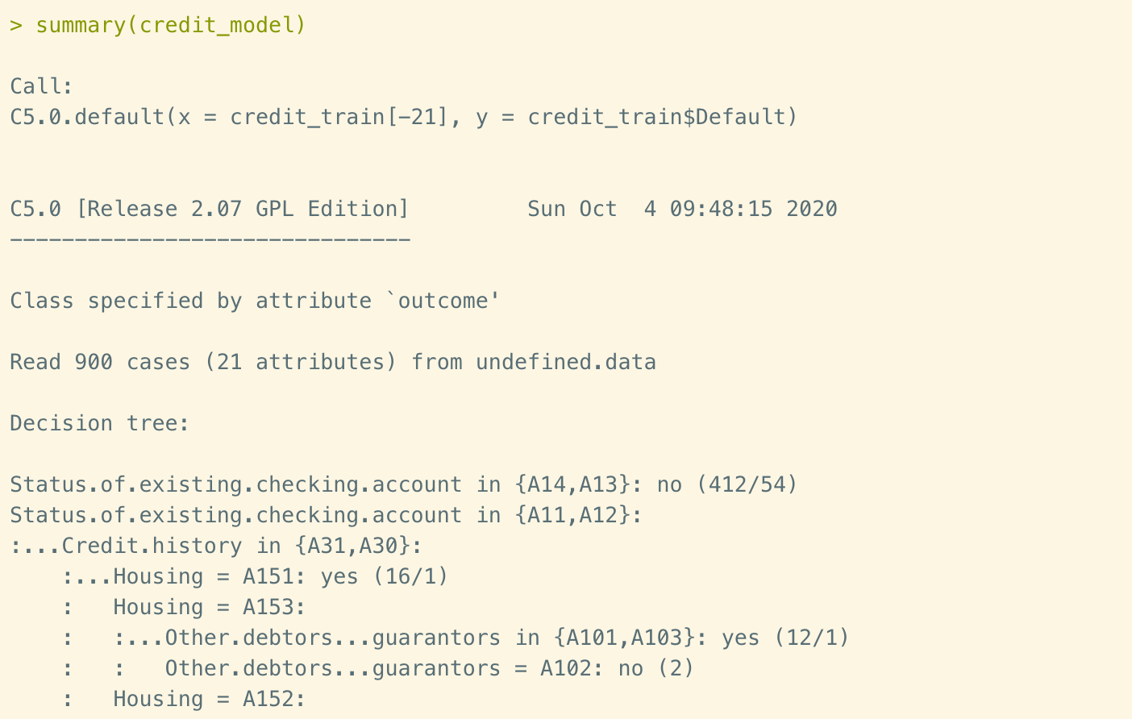
Figure 6. Decision trees summary
In this output snapshot we could see few of the first branches in the decision tree: if the status of existing checking about “unknown” or “>= 200 DM”, then classify as “not likely to default”. If not, then move to credit history that is “no credits taken/all credits paid back duly” or “all credits at this bank paid back duly”. If the housing status is rent, then classify as “likely to default”.
There is also an evaluation table in summary shown as below.
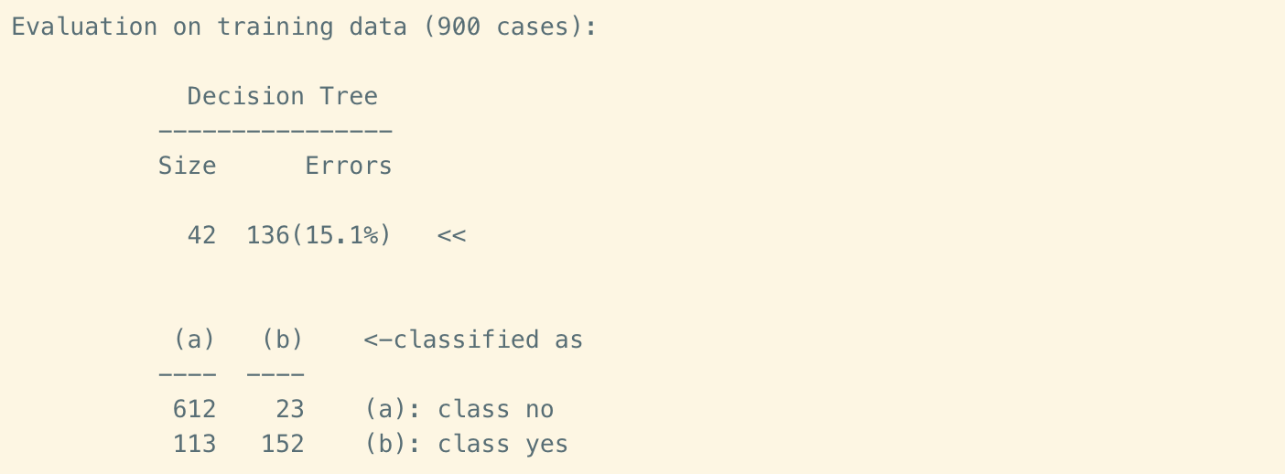
Figure 7. Decision trees evaluation
There are about 84.9% training instances are correctly classified. In the error output, 113 yes values are misclassified as false negatives.

Step 4 – evaluating model performance
Apply the model that we created from the previous step to the test data and get evaluation table as below.
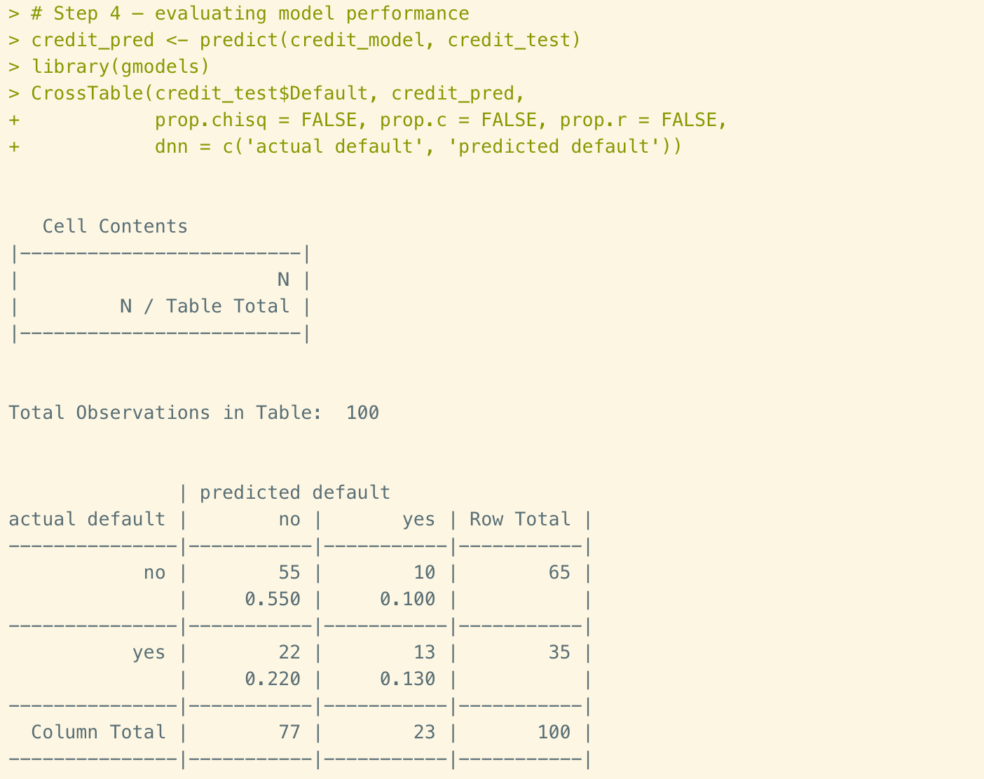
Figure 8. Decision tree evaluation
In this table, we could also see an accuracy of 68%, which is even lower than the training data. Furthermore, the model has incorrectly predicted 22 out of 35 actual defaults observations in the test data, or 63%. Since the bank will lose money on default cases, this model needs to be improved.

Step 5 – improving model performance
One way C5.0 algorithm could make to improve the performance is called adaptive boosting. This is an idea of considering that every model has a unique set of strengths to weaknesses to solve certain problems. Therefore, we would like to complement these points by using a combination of several learners to increase the accuracy.
In practice, we simply add an additional trials parameter to limit the upper number of trees when it realized that no more trials were necessary. Now let’s try boost10 vector and see its performance.
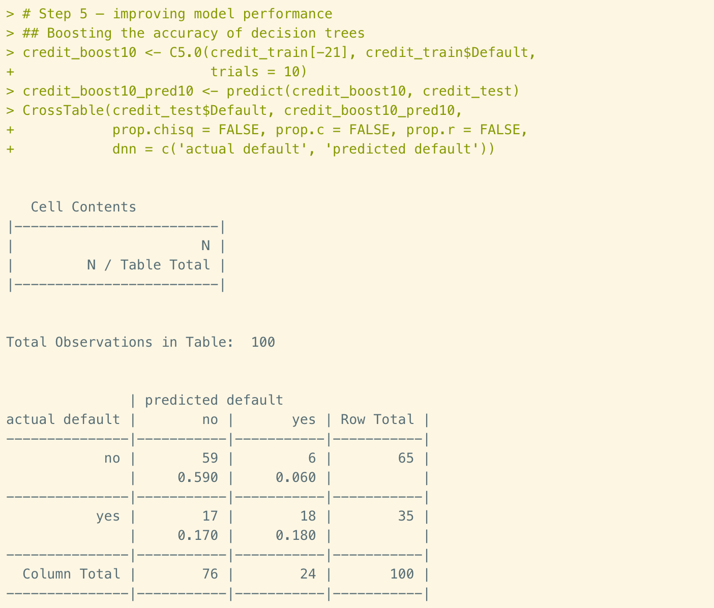
Figure 9. Decision tree evaluation
This time we’ve got an accuracy of 77% in test data. this is 9% better than before, but still relatively low. And the false negative rate is still as high as 17%. Or say almost half of actual default observations were failed to be detected.
Another way to make improvement in C5.0 algorithm is cost matrix. This is an idea of discouraging a tree from making mistakes. In this case, we are going to make a 2x2 matrix and assign the penalty for errors.
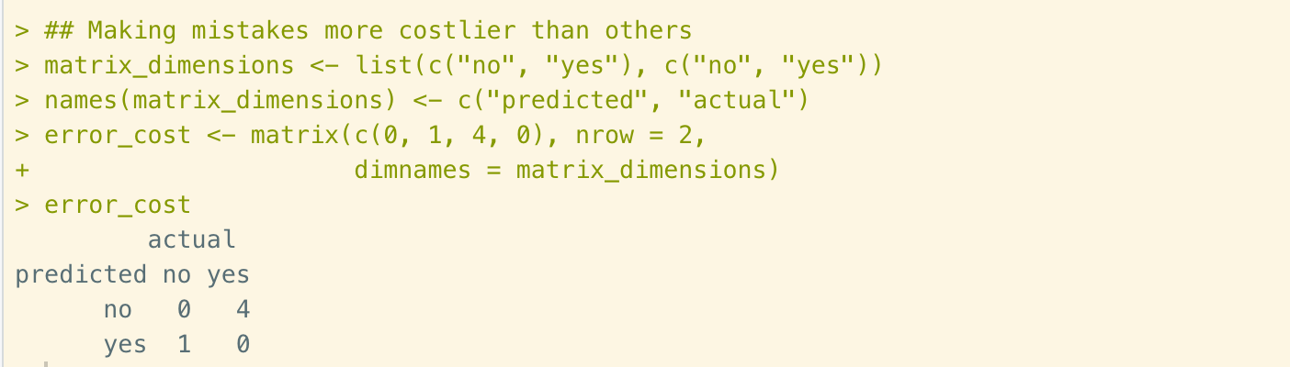
Figure 10. Generate cost matrix
Then apply it to the previous decision trees.
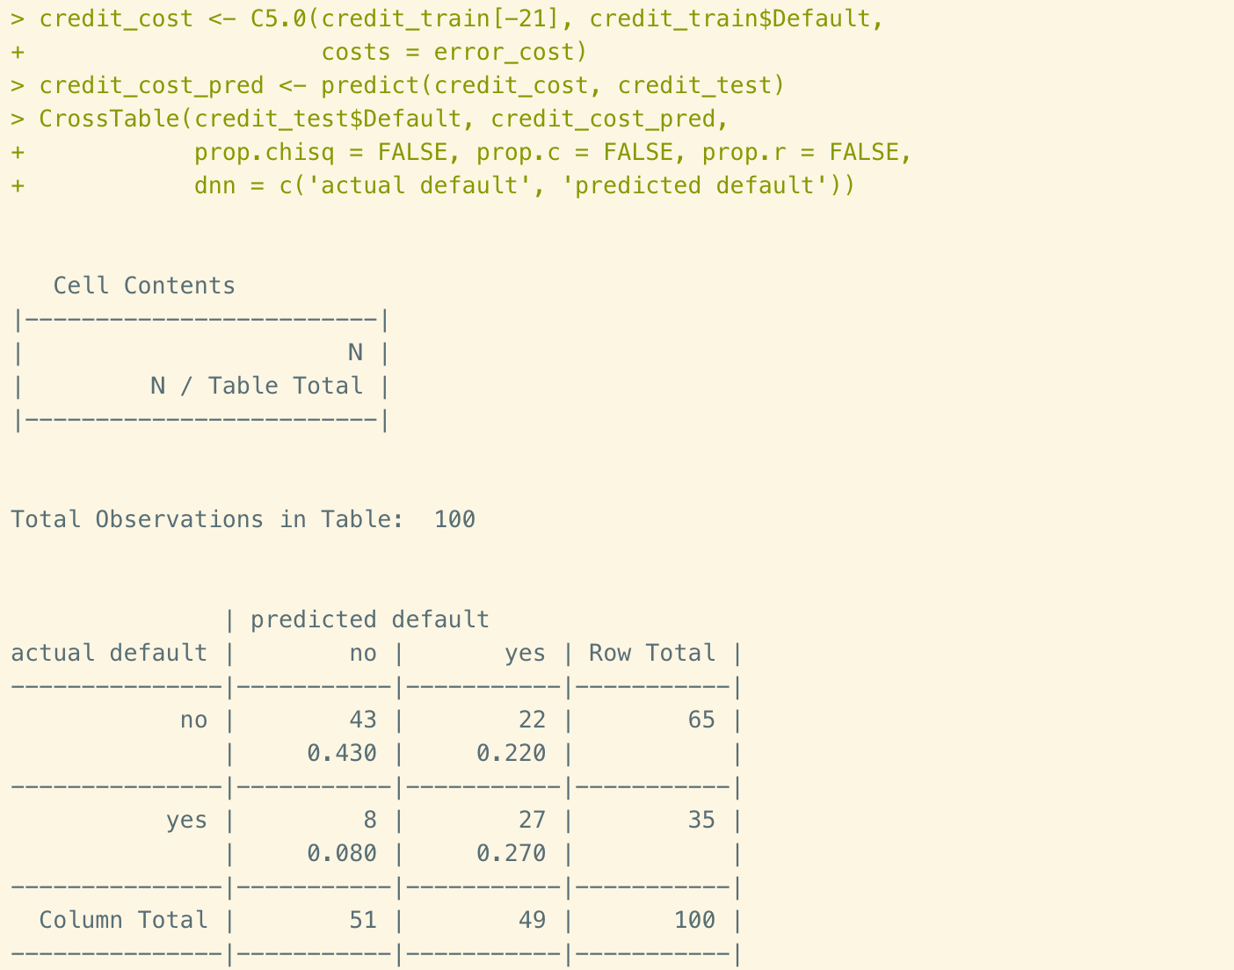
Figure 11. Performance evaluation
As we could see from the evaluation table, the overall accuracy is as plain as 70%. But the false negative rate is now 8%. This is considering a notable improvement.

Mushroom Data Set
In this part, we are going to go through the mushroom dataset and built rule learners to get an easy-to-understand rule to distinguish poison mushrooms.

Step 1 – collecting data
In this dataset, there are 8,124 observations of 23 variables. Now let’s import the dataset and get a glance of the structure.

Step 2 – exploring and preparing the data
Here is the structure of mushroom data.
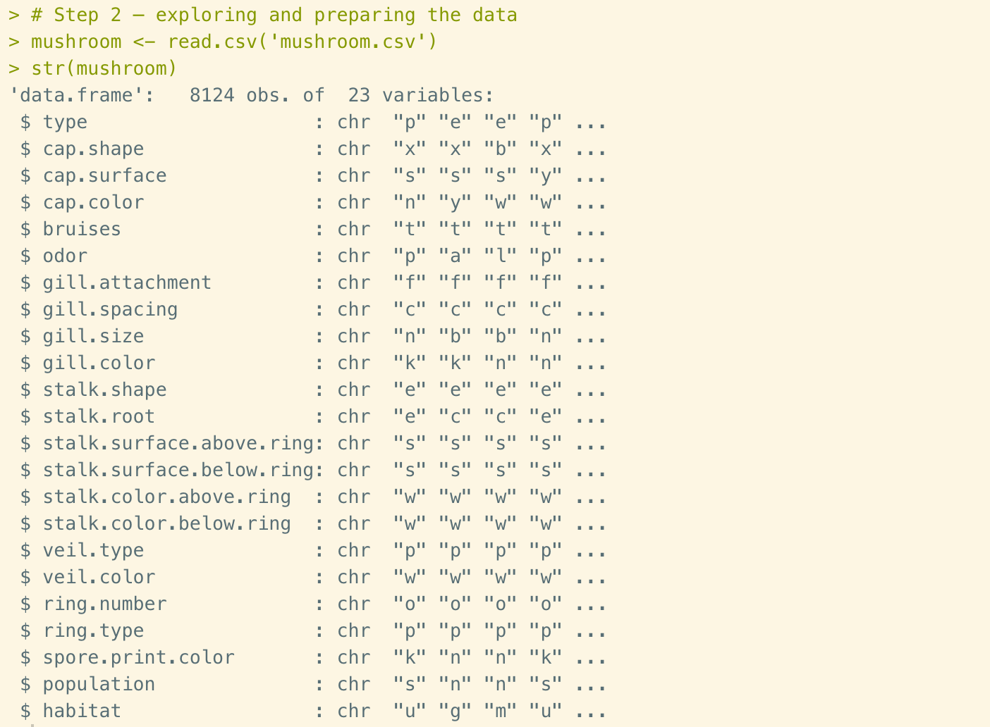
Figure 12. Mushroom Data
One thing is worth to mention is that there is only one level appeared out of two levels that listed in the dictionary in vector “veil.type”. This is likely a coding error. Fortunately, the veil type doesn’t provide crucial role in this model, so we could drop this variable from our model by using NULL command. Then we’ll also relabel the type of mushrooms in column 1 and take a look at the table of mushroom types.
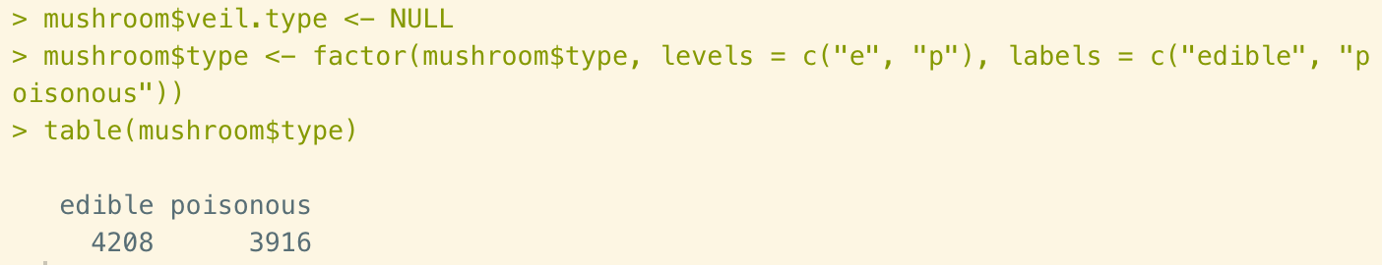
Figure 13. Mushroom type portion
There are about 52% of mushrooms are edible, and the rest of them are poisonous. In this case, we are considering the dataset of 8,214 samples is the entire set of population. We are not designing to cover unforeseen types of mushrooms. The purpose of our model is to find rules that could accurately depict all the current known mushrooms. Therefore, we don’t need to split the dataset at this time.

Step 3 – training a model on the data
In this step we are going to use OneR() function to generate rules based on the entire dataset. The function this shown as below:
M <- OneR(class ~ predictor, data = mydata)
In this formula, the ~ operator indicates the relationship between the target variable and its predictors. The predictors could be separated by “+”, or use “ .” to include all features in the dataset. In our case, we are going to allow the rule learners to consider all the possible features to predict the type.
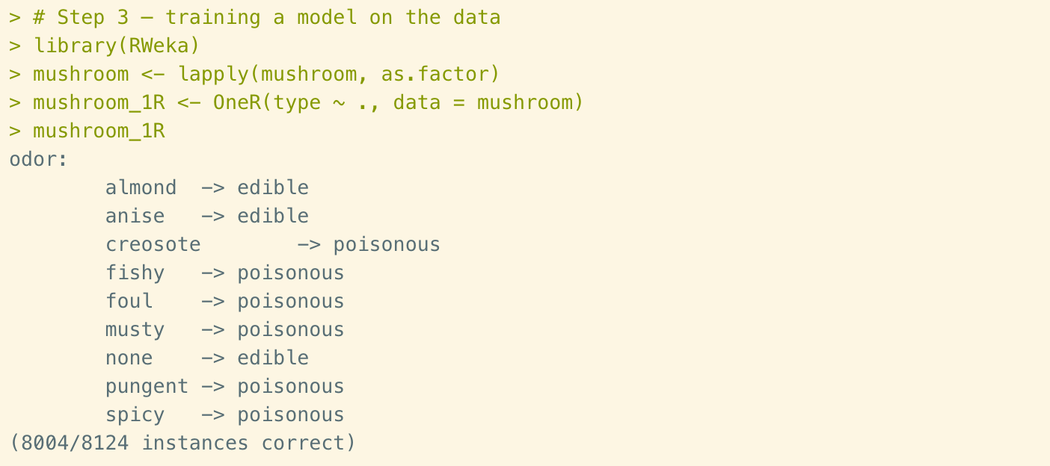
Figure 14. Training the model
In this result we could see that odor is being selected as the rule generation. The categories of odor are listed to specify rules for classify mushrooms. For example, mushrooms with pleasant smells such as almond or anise, or those that don’t have smells, are classified as edible. Therefore, for the purposes of field guide, we could put following instruction: “mushrooms with unpleasant smells are likely to be poisonous.”

Step 4 – evaluating model performance
Use summary() function to get the evaluation table in R.
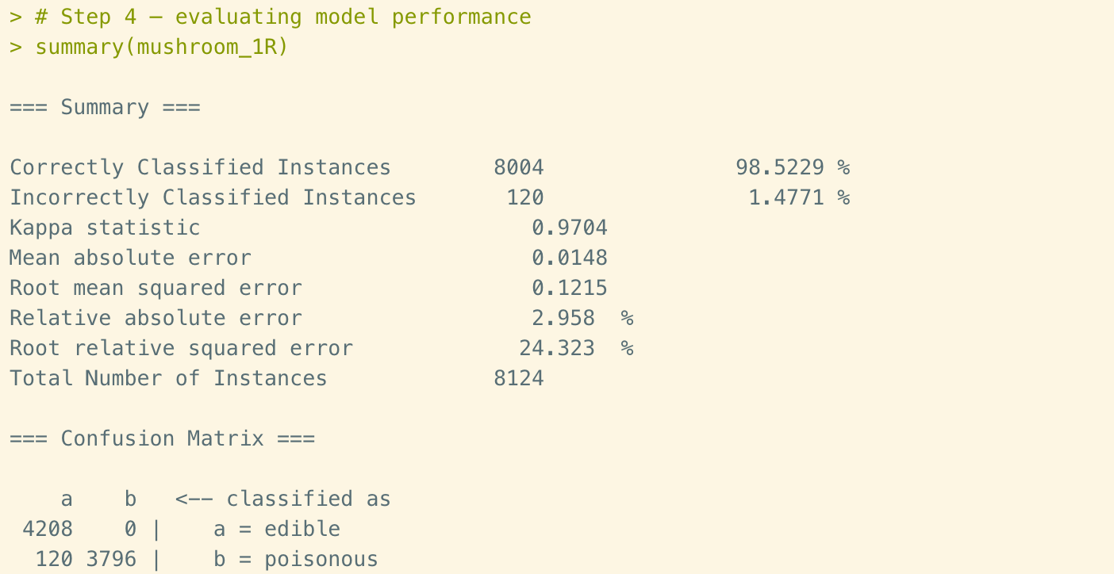
Figure 15. Evaluation table
In the first line of the summary shows that the accuracy is about 98.5%. But when we check out the matrix in bottom, there are 120 poisonous mushrooms are incorrectly classified as edible. This is an incredibly dangerous mistake. Lessons learned is that only one feature utilizes a learner could perform reasonably well, but not good enough when there are lives involved. So, in the next step, we are going to find ways to improve the accuracy by adding more rules in our classifier.

Step 5 – improving model performance
To add more rules, we are going to use JRip() function. The formula is shown as below:
M <- JRip (class ~ predictors, data = mydata)
The process of training rule learners is as same as with OneR().
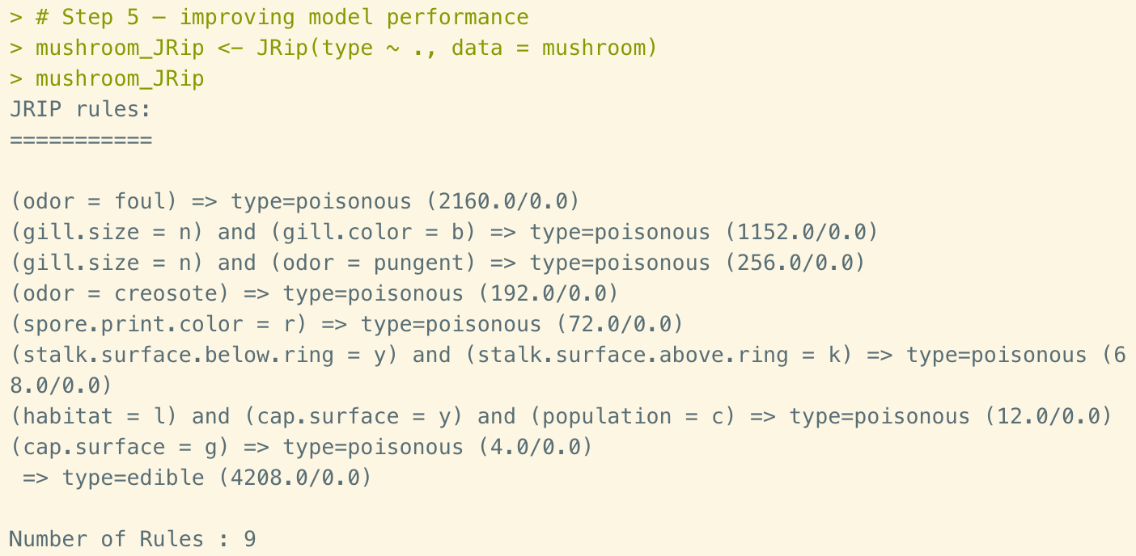
Figure 16. Training rule learner by JRip()
In this result, there are 9 rules that we are using to classify mushrooms. Similar as how we read the rules in Decision tree, we could use if-else statements on this result. For example, if the odor is foul, then the mushroom is poisonous. If the grill size is n(as in narrow) and the gill color is b(as in buff), then the mushroom type is poisonous.
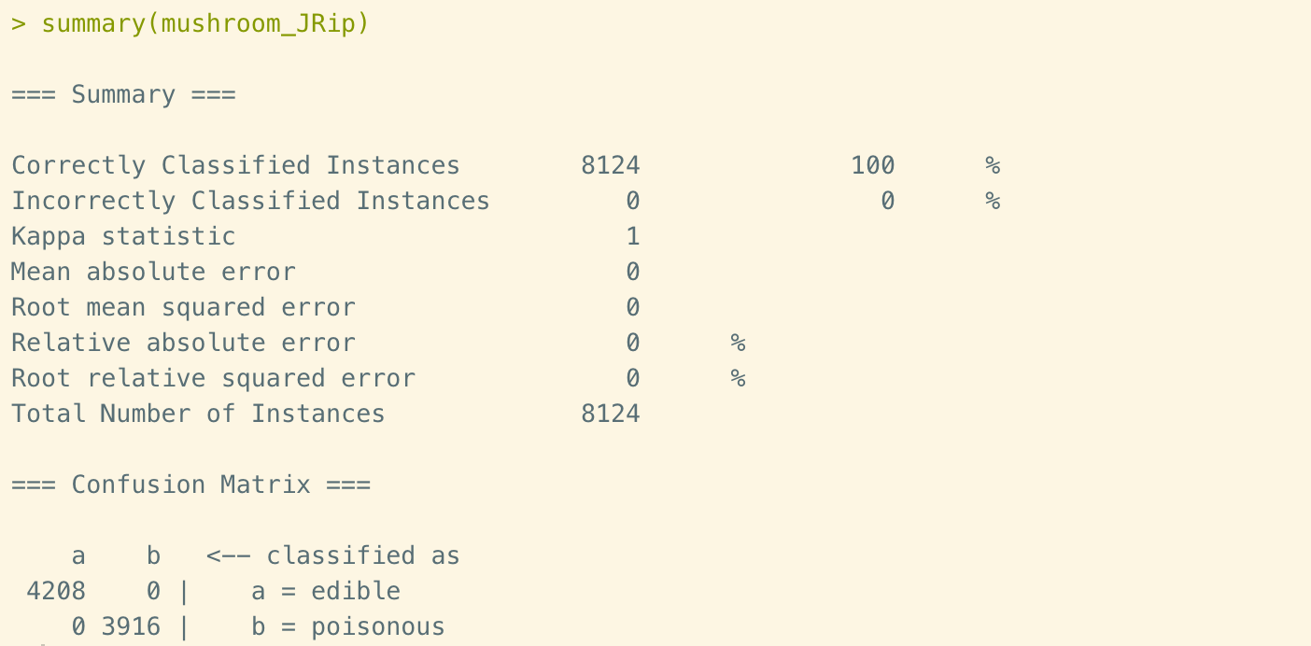
Figure 17. Evaluation table by JRip()
In the summary page we could see that the accuracy is 100%. In the matrix below we could be double sure that the false negative and false positive are both 0. So now we could be satisfied by the result of our rules learner.

Conclusions
In this report we practiced two classification methods, the Decision trees and Rule learners. Decision trees generate flowchart structures to classify data, while the Rule learners list bunch of if-else rules to distinguish features in dataset. Both methods are easy to process, even for non-analytics people. For performance improvement, Decision trees use boosting and cost-sensitive errors to increase the accuracy and decrease the number of false negative. The Rule learners use 1R to utilize only one feature, which is easy to understand as a quick guidance. To get a higher accuracy, the Rule learners use RIPPER, which could add more features to get a 100% accuracy in our case.

Reference
- Lantz, B. (July 2015). Chapter 5: Divide and Conquer – Classification Using Decision Trees and Rules. In Machine Learning with R (2nd ed., pp. 125-169). Birmingham, UK: Packt Publishing.
- Machine Learning Repository. (1994, November 17). Statlog (German Credit Data) Data Set [Data file]. Retrieved from https://archive.ics.uci.edu/ml/datasets/statlog+(german+credit+data).
- Machine Learning Repository. (1987, April 27). Mushroom Data Set [Data file]. Retrieved from http://archive.ics.uci.edu/ml/datasets/Mushroom.

